# ­ US_001: Login Page

|  |  |
| --- | --- |
| Description | As a customer, I want to login with my credentials so I can securely access my online account |
| Assigned To | PO (Product Owner) |
| State | Ready / In Design / Done / In Review |
| Priority | High |
| Risk | High |

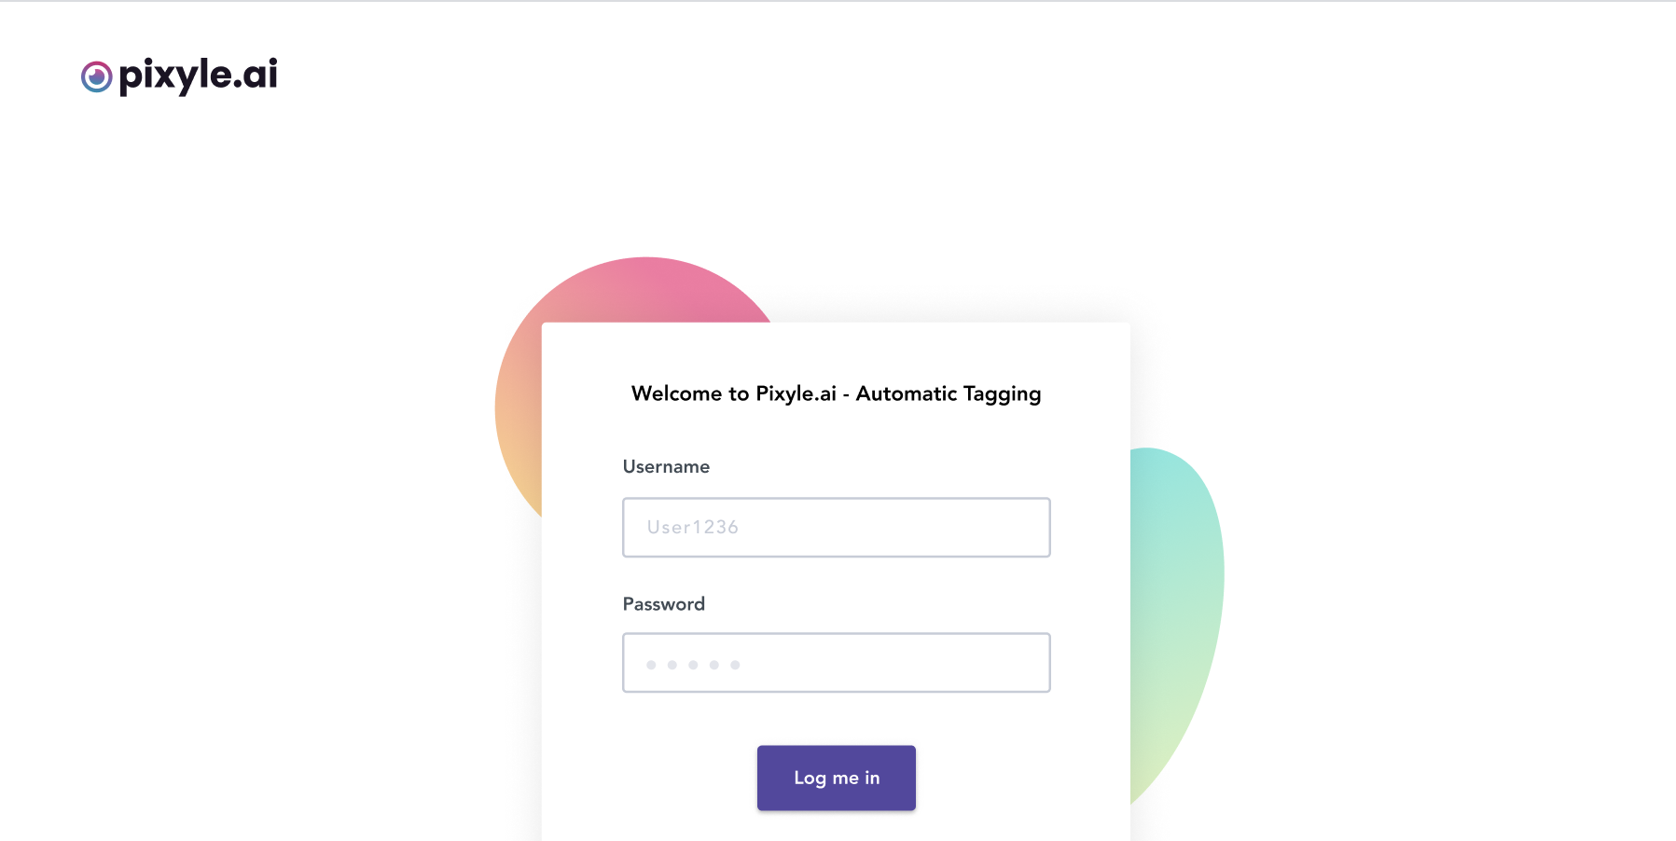

Acceptance Criteria:

|  |  |
| --- | --- |
| Username | Input type field with 256 max chars |
| Password | At least 7 chars, 1 number, 1 uppercase letter, 1 lowercase letter, 1 special char |
| Log Me In | Type Button |

All fields are required data fields - error alert should be shown if user clicks on “Log Me In” button without typing anything in the required fields.

Password entries will show the keystroke typed, and then after certain time (1s) the entered character is masked.

Green check mark next to 'Password' data field should be displayed that indicates to the user after typing password that the entry meets criteria

Red mark next to 'Password' data field should be displayed that indicates to the user after typing password that the entry does not meet criteria

After successful validation of all entered fields and on clicking “Log Me In” button, a confirmation message for successful login appears.

# ­ US_002: Pixyle Reset Login Credentials:

|  |  |
| --- | --- |
| Description | As a customer, I want to login with my credentials so I can securely edit/modify my online account |
| Assigned To | PO (Product Owner) |
| State | Ready / In Design / Done / In Review |
| Priority | High |
| Risk | High |

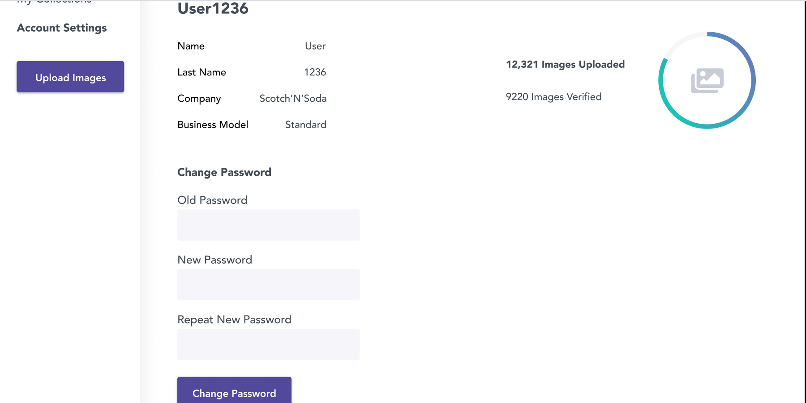

Acceptance Criteria:

|  |  |
| --- | --- |
| Old Password | At least 7 chars, 1 number, 1 uppercase letter, 1 lowercase letter, 1 special char |
| New Password | At least 7 chars, 1 number, 1 uppercase letter, 1 lowercase letter, 1 special char |
| Repeat New Password | At least 7 chars, 1 number, 1 uppercase letter, 1 lowercase letter, 1 special char |
| Change Password | Type Button |
| Name | Label (text) – non editable |
| Last Name | Label (text) – non editable |
| Company | Label (text) – non editable |
| Business Model | Label (text) – non editable |

'Old Password', ‘New Password' and ‘Repeat New Password'’ entries should be masked  
Password entries will show the keystroke typed, and then after certain time (1s) the entered character is masked.

If 'Old Password' entry does not match criteria specified and user hits Change Password, error alert "Password entry does not meet criteria" will be shown.

If entries in 'New Password' and Repeat New Password' do not match and user hits Change Password, error alert 'Password entries do not match' is shown.

After successful validation of all entered fields and on clicking Change Password button, message is shown indicating successful account modification.

**Test Suite 1: Automatic Tagging Authentication**

AT_UAT 1.1: Login with invalid credentials

|  |  |  |
| --- | --- | --- |
| Description | This test script covers login with invalid credentials | |
| Link to User Story | PIXYLE_AT_US.pdf 2-4/53 | |
| Assigned To | **Andreja Misevski** | |
| State | Done | |
| Priority | High | |
| Risk | High | |
| Status | PASS | |
| Product | Pixyle | |
| Type | Regression | |
| Automation | **Automated** | |
| Configuration | Windows 10 | |
| Prerequisites | Chrome Version 80.0.3987.116 (Official Build) (64-bit) | |
| Action | | **Expected Result** |
| Open Chrome and enter <https://www.pixyle.ai/>Login | | User successfully navigates and lands on page where a content area with title “Welcome to Pixyle.ai – Automatic Tagging”, Username, Password and Log Me In button are shown.  At the bottom of the form there is a text “Problem logging in? Contact Us so we can solve it right away” where the User is able to click on the link Contact Us. |
| Use {EMPTY} Username and Password and click on the Log Me In button | | “Alert” appears notifying the User with the message “Incorrect Login.” |
| Type any nonexistent user (ex. SomeUser) in the Username input field and click on the Log Me In button | | “Alert” appears notifying the User with the message “Incorrect Login.” |
| Use {EMPTY} Username with existing correct Password and click on the Log Me In button | | “Alert” appears notifying the User with the message “Incorrect Login.” |
| Type correct Username in the Username input field and wrong password in the Password field | | “Alert” appears notifying the User with the message “Incorrect Login.” |
| Type correct Username in the Username input field and add space on the end. Use correct password corresponding the User from above in the Password field | | “Alert” pop up window appears notifying the User with the message “Incorrect Login.” |
| *try any other combination of invalid login | | / |

­ AT_UAT 1.2: Login with valid credentials

|  |  |  |
| --- | --- | --- |
| Description | This test script covers login with valid credentials | |
| Link to User Story | PIXYLE_AT_US.pdf 2-4/53 | |
| Assigned To | **Andreja Misevski** | |
| State | Done | |
| Priority | High | |
| Risk | High | |
| Status | PASS | |
| Product | Pixyle | |
| Type | Regression | |
| Automation | **Automated** | |
| Configuration | Windows 10 / Windows 8.1 / Windows 7 (XP not supported) MAC | |
| Prerequisites | Chrome Version 80.0.3987.116 (Official Build) (64-bit) | |
| Action | | **Expected Result** |
| Open Chrome and enter <https://www.pixyle.ai/>Login | | User successfully navigates and lands on page where a content area with title “Welcome to Pixyle.ai – Automatic Tagging”, Username, Password and Log Me In button are shown.  At the bottom of the form there is a text “Problem logging in? Contact Us so we can solve it right away” where the User is able to click on the link Contact Us. |
| Log In with Valid Credentials | | User has logged in successfully in the application and lands on the “My Collections” page. |

­ Pixyle 1.3: Log Out

|  |  |  |
| --- | --- | --- |
| Description | This test script covers Logging out current user and verification that the same has landed on the Login Page | |
| Link to User Story | US_003 (tbd) | |
| Assigned To | QA Manual Tester | |
| State | Ready / In Progress / Done / In Review | |
| Priority | High | |
| Risk | High | |
| Status | PASS | |
| Product | Pixyle | |
| Type | Regression | |
| Automation | Automated / Can Not Be Automated / In Progress | |
| Configuration | Windows 10 / Windows 8.1 / Windows 7 (XP not supported) MAC | |
| Prerequisites | Chrome version x.x.x or above / Android Version x.x.x or above / IOS | |
| Action | | **Expected Result** |
| Open Chrome and enter <https://www.pixyle.ai/>Login | | User successfully navigates and lands on page where a content area with title “Welcome to Pixyle.ai – Automatic Tagging”, Username, Password and Log Me In button are shown.  At the bottom of the form there is a text “Problem logging in? Contact Us so we can solve it right away” where the User is able to click on the link Contact Us. |
| Log In with Valid Credentials | | User1236 is logged in successfully in the application and lands on the “My Collections” page.  Within the main panel there is a table of content with following columns that the user can/cannot sort/filter/search by:   * Folder Name * Number of images * Verified Images * Competition   The User is able to delete an item. |
| Click on the User1236 (ddl item) on the top right corner of the application and click on Log Out | | The User lands on the Login form and is logged out of the application successfully |
| Click on the back button of the browser | | Ensure that the User is not able to navigate back to the last state/session of the application. |